Response to Reviewers
Manuscript ci-2026-030865 — “Molecular Simulation of Doravirine Resistance in HIV-1 Reverse Transcriptase”
Rohit Satija, Kaiming Tao, Robert W. Shafer
Response: We thank the editor and the three reviewers for a careful and constructive set of critiques. We believe the updates made due to these reviews have significantly strengthened the manuscript. Reviewer comments are reproduced below in blue and our responses are in red/black. All changes to the manuscript and the supplementary text are marked in red in accompanying revised files.

Reviewer 1
Comments:
This is a methodologically solid study that asks a genuinely useful question: whether relative RT–DOR binding free energies, computed from molecular simulation, track phenotypic resistance across a clinically representative genotype panel. Several individual cases, particularly Y188L and V106A, give a convincing structural account of altered DOR recognition, consistent with prior crystallography.
The deeper limitation is conceptual rather than computational: the manuscript treats the sampled DOR-bound pose (inherited unmodified from the crystal structure) as representative of the relevant binding ensemble, without testing that assumption. Because the NNRTI pocket only forms upon ligand binding, and RT itself rearranges on timescales far longer than the 100 ns simulated here, that assumption is precisely what the manuscript's own inconsistent results (Section 3, below) call into question.
Response: We thank the reviewer for this framing. The concern is that one crystal structure fixes the starting pose that every simulation then inherits, with the underlying assumption that this starting pose is representative of the true RT-DOR binding ensemble. We have tested this assumption directly against a second, independent experimental structure of the same complex, and separately against alternative starting poses.
To address this comment, we have added a new section to the Supporting Information:
“ 1. Is the RT-DOR crystal structure representative of the true RT-DOR structural ensemble?
We address this question in two steps: first by comparing the DOR pose in the crystal structure (PDB ID: 4NCG) with a second, independent RT-DOR-DNA ternary structure determined by cryo-EM (PDB ID: 7Z2G), and then by quantifying changes in key residues of the NNIBP, using other published structures of NNRTI complexes as a reference set. For all comparisons, we align 16 NNIBP-lining Cα atoms of 4NCG, fifteen in p66 and Glu138 in p51. 7Z2G is a 3.65 Å single-particle cryo-EM structure of HIV-1 RT bound to a 38-mer DNA aptamer and DOR, determined by a different group, by a different method, and in a different functional state from the 2.58 Å X-ray structure 4NCG. Superposed on the pocket Cα atoms alone, DOR agrees between them to 0.62 Å heavy-atom RMSD over its 29 atoms, with a centroid displacement of 0.30 Å (Supplementary Figure 1A). Fitted ligand on ligand, its internal conformation agrees to 0.44 Å, no ring system is placed differently from the rest, and the four rotatable dihedrals agree to within 15°. The pocket agrees to 0.49 Å over the same Cα atoms and to a median side-chain RMSD of 0.80 Å, and the NNIBP volume is 198 Å³ in 4NCG against 194 Å³ in 7Z2G. Per-residue values are in Supplementary Table 8. Furthermore, even without any superposition, the minimum heavy-atom distance from each NNIBP residue to DOR agrees between the two structures to a median of 0.16 Å, with the largest discrepancy of 0.41 Å at Lys103 and a correlation of r = 0.974 across the sixteen residues.
To calibrate these alignment results, we applied the identical superposition to three further complexes of wild-type RT with an NNRTI: RPV (2ZD1, 1.80 Å), EFV (1FK9, 2.50 Å) and NVP (1VRT, 2.20 Å). Tyr181 occupies a different rotamer in the DOR structures than in all three others: its χ1 angle differs from 4NCG by 93°, 95° and 90° respectively, displacing the ring centroid by 4.9, 4.2 and 4.2 Å (Supplementary Figure 1B). The NNIBP volume across the five structures ranges from 181 to 258 Å³. Furthermore, Tyr188 χ1 differs by only 13–20° and its ring centroid by 1.3–2.6 Å across all five structures (Supplementary Figure 1C). Per-structure values for both tyrosines are in Supplementary Table 9. Taken together these results support the claim that the DOR-containing NNIBP conformations are the same in two experimental structures determined independently, while the same pocket demonstrably adopts a different conformation when it holds other drugs in the same class. The starting geometry of this work is therefore a property of the DOR–RT complex rather than an artifact of one crystal form.

Supplementary Figure 1. The DOR-NNIBP pose is reproducible across independently determined RT-DOR structures. (A) Doravirine in the two independent experimental structures, 4NCG (X-ray, 2.58 Å, grey) and 7Z2G (cryo-EM, 3.65 Å, blue), with the 4NCG pocket side chains in faint grey; heavy-atom RMSD 0.62 Å over 29 atoms. (B) Tyr181 in five NNRTI complexes: 4NCG (grey) and 7Z2G (blue) against rilpivirine 2ZD1 (red), efavirenz 1FK9 (orange) and nevirapine 1VRT (purple). The two DOR structures agree with each other and differ from the other three by 90–95° in χ1. (C) Tyr188 in the same five structures, which share one rotamer and differ by only 13–20°. Doravirine from 4NCG is drawn faintly in (B) and (C) for orientation.”

Reviewer 1, comment 1
Major comments:
1. Weak correlation with phenotype. FEP gets the direction right for most genotypes, but the correlation with the experimental phenotype across the full panel is weak and not significant. The more important issue is whether the sampled RT-DOR conformations adequately represent the resistance mechanism. The weak correlation may therefore reflect not only limitations of the free-energy calculation, but also resistance mechanisms involving mutation-induced changes in RT conformation and NNIBP formation.
Response: We agree that our results do not establish a strong correlation between binding energy changes and phenotypic susceptibility reduction due to drug-resistant mutations. Moreover, this result is confounded by our modeling approach of utilizing the simplest RT-DOR system (as opposed to including DNA template/primer and/or dNTPs in the simulations) and direct binding energy calculation (as opposed to, say, modeling nucleotide incorporation or other events necessary for HIV RT function). We hope that our study inspires future work that overcome these challenges in modeling DOR-associated resistance.
To address this comment, we have updated the Discussion section:
“

”

Reviewer 1, comment 2
2. Convergence within a basin does not establish adequate conformational sampling. Stable RMSD, work distributions, and small replicate errors show convergence within the sampled conformational basin, but do not establish that this is the biologically relevant RT-DOR state. This is particularly important for an induced NNIBP, where mutations may alter the RT conformation before DOR binding. The authors should address this in two ways:
- First, test representative systems from independent starting poses to determine whether the same DOR-bound state is recovered.
- The authors should perform longer-timescale apo simulations for a selected set of mutants, particularly P225- and M230-containing genotypes, and compare the resulting RT and pocket conformational ensembles with WT. These mutations are located in loop-rich regions and could affect pocket formation through slower conformational remodeling that is not captured in the current simulations.
Response: To address the first bullet point, we have performed a new set of simulations, details of which are added in the Methods section:
“ Convergence tests
To test whether the sampled DOR-bound state is recovered starting from gradually extreme perturbations to the starting configuration, alternative DOR poses were generated by random rigid-body placement within the NNIBP, screened to keep every ligand–protein heavy-atom contact above 2.2 Å, and accepted in 0.5 Å wide bands of heavy-atom RMSD from the crystallographic pose. Sixteen poses spanning 1.3 to 6.8 Å were prepared, minimized and simulated exactly as the production systems, one replicate each, but for 2 ns and without the 0.1 Å coordinate jitter used to decorrelate the production replicates. Endpoint pose coordinates are reported after superposition on the NNIBP Cα atoms as the DOR heavy-atom RMSD from the crystallographic pose, the displacement of the DOR centroid and the tilt of its long axis.”
The corresponding results are summarized in the Supplementary Information:
“ 2. The crystallographic pose is recovered from perturbed starting poses
To test whether representative systems from independent starting poses can recover the same DOR-bound state used in the simulations, we ran energy minimization followed by 2 ns MD equilibrations for a ladder of sixteen starting poses at increasing distance from the crystallographic pose. In the wild-type (WT) production ensemble, the DOR pose RMSD lies between 0.33 and 1.78 Å, the centroid displacement is at most 1.75 Å and the long-axis tilt at most 15.1°; we take that envelope as the sampled WT basin. All ten poses starting between 1.3 and 2.9 Å converged into the WT basin, ending at a median pose RMSD of 0.74 to 1.01 Å with 78 to 100% of their frames inside the envelope. However, extreme perturbations, corresponding to the six poses starting at 3.3 Å or beyond, failed to converge to the WT basin in the 2 ns simulations, ending between 5.0 and 9.4 Å (Supplementary Figure 2). The crystallographic pose is therefore an attractor with a basin of, at least, roughly 3 Å DOR pose RMSD from the crystal structure used in this study.

Supplementary Figure 2: Perturbed doravirine poses against the wild-type sampled basin. Axes are the pocket-frame coordinates after superposition on the NNIBP Cα atoms: centroid displacement separates translation, long-axis tilt separates rotation. Blue shading and contours give the density of the wild-type production ensemble (3 × 100 ns) enclosing 50, 90 and 99% of frames; the star is the crystallographic pose. Each run is drawn as an arrow from its starting pose, labelled with its heavy-atom RMSD as generated, to the median of its second half (last 1ns of the equilibration simulation). Green ends inside the basin, red outside. (A) All sixteen poses. (B) The same data over the convergent region.”

Reviewer 1, comment 3
3. The mismatches suggest different resistance mechanisms. The mismatches between calculated ΔΔGbind and the experimental phenotype are not simply random errors and should be discussed mechanistically. For example:
- K103N+M230L shows only a small calculated binding penalty despite 36-fold resistance.
- A98G+F227C and G190E show substantial resistance despite favorable calculated ΔΔG_{bind}. G190E is particularly notable because it produces the largest pocket expansion, yet no binding penalty. The authors should examine whether mutation-induced changes occur in both apo and holo RT and whether such remodeling could therefore be poorly reflected in ΔΔG_{bind}.
Response: We agree that these are not random errors. The thermodynamic-cycle cancellation the reviewer describes is the explanation we had reached, and the apo simulations the reviewer asks for are the basis for it. We have extended that analysis, moved its numbers into the Results where they belong, and added the literature that bears on the G190E case.
To address this comment, we have added this paragraph in the Methods section:
“Unliganded RT simulations. Apo systems were built by removing DOR from the corresponding prepared holo structure and were solvated, minimized, heated and run under the same protocol. The NNIBP volume was computed per frame as above, and the pocket-opening cost reported as the holo minus the apo volume for the same genotype. Apo replicates differ in length, so volumes were compared on a window common to all of them. Frames in which the pocket-lining Cα atoms were no longer a compact cluster, defined as a radius of gyration above 10 Å, were excluded; this affected one G190E replicate and one K103N+M230L replicate, in both cases because the subunit unfolded locally. The apo cavity was not re-solvated with bulk water before measurement, which biases apo volumes low, so the reported openings are upper bounds.”
To address this comment, we have added this subsection in the Results section:
“The unliganded pocket and the cost of opening it”
“The NNIBP is not an open cavity in unliganded RT, so DOR binding must pay a conformational cost. We measured that cost by simulating the unliganded enzyme and subtracting the apo NNIBP volume from the holo value for the same genotype (Supplementary Table 7). The unliganded pocket is smaller than the bound pocket in every genotype, by 104 to 223 Å³, and the simulated wild-type apo volume, 76 ± 9 Å³, lies below the unliganded crystal structures 1DLO (102 Å³) and 1HMV (104 Å³), while the DOR-bound 4NCG value of 198 Å³ lies well above all three.”
“Wild type pays 152 ± 15 Å³ to open the pocket. Of the three genotypes whose ΔΔGbind misses the phenotype, only G190E pays significantly more, by 71 ± 26 Å³ (2.7 standard errors, 95% interval excluding zero); A98G+F227C (22 ± 19 Å³) and K103N+M230L (2 ± 28 Å³) are within error of wild type. Nor is a large nominal cost specific to the mismatched genotypes: V106I, Y188L and V106I+F227C pay 40 ± 17, 35 ± 23 and 19 ± 25 Å³ more than wild type, none of them resolved at three replicates, and for these three ΔΔGbind tracks the phenotype. What distinguishes the mismatched genotypes is that they pay this cost without losing contact with DOR once bound: G190E keeps chlorocyanophenyl burial above wild type, 22.7 ± 2.0 against 19.5 ± 0.5, and a stacking angle closer to coplanar, 12.0 ± 0.9°, whereas Y188L loses about a third of that burial, 13.7 ± 1.5 (Table 3).”
To address this comment, we have extended this paragraph in the Discussion section:
“Several genotypes show inconsistencies between ∆∆ETotal and ∆∆Gbind, which is not surprising. The two measure different quantities, the interface energy of the bound complex versus the energetic difference between bound and unbound states.34 G190E and A98G+F227C both distort the DOR–RT interface (∆∆ETotal = 1.94 ± 0.40 and 2.47 ± 0.24 kcal/mol), but comparable distortion is present in the apo simulations, so the penalty largely cancels in the thermodynamic cycle and the residual favors binding (∆∆Gbind = −1.02 ± 0.38 and −1.53 ± 0.87 kcal/mol). Similarly, for K103N+M230L, our calculations suggest negligible binding penalty (∆∆Gbind = 0.59 ± 0.41 kcal/mol) despite a 36-fold reduction in susceptibility (Table 1). Structural metrics suggest DOR interface is unperturbed — chlorocyanophenyl burial is the second highest in the panel, 22.8 ± 2.4 against 19.5 ± 0.5 in WT, and the Lys103 anchor is intact at 3.05 ± 0.04 Å (Table 3). Interestingly, Met230 lies in the p66 primer grip, where its side chain contacts the primer terminus,79 and M230L impairs RT enzymatic function and viral replicative capacity in addition to reducing NNRTI susceptibility.80 Our system is a binary RT–DOR complex containing no template/primer, so a resistance mechanism acting through that interface is absent from our simulations and, therefore, outside the scope of our measurements. A change in the primer grip, in how the template is held, or in how often RT adopts a catalytically active shape would not affect ΔΔGbind or ΔΔETotal as measured in the present study, yet could still lower susceptibility in host cells. The same comparison localises what nucleic acid changes: with the p66 palm as the reference frame, p51, the fingers and the thumb differ by 1.6–2.2 Å between the two structures while the NNIBP lining differs by 0.97 Å, so the mechanisms we cannot reach without nucleic acid are those that act through those subdomains rather than through the drug site itself. For G190E a second factor concerns the phenotype rather than the calculation. Substitutions at position 190 impair replication severely: a site-directed G190E virus replicates too poorly for its NNRTI susceptibility to be determined at all, and patient-derived G190E viruses replicate at 20–60% of reference only because they carry compensatory substitutions elsewhere in RT and in Gag-PR, most often L74V or V75. The clinical fold-change we compare against is therefore measured on viruses that are not G190E alone, while our calculation changes one residue in an otherwise wild-type enzyme, so part of this mismatch is a difference in what is being measured.”
Two points are worth drawing out. First, the pocket-opening cost separates only G190E from wild type at three replicates, so it cannot by itself account for the other two mismatches: V106I, Y188L and V106I+F227C pay nominally more than wild type and ΔΔGbind tracks the phenotype for all three, while A98G+F227C and K103N+M230L pay no more than wild type within error. What distinguishes G190E is not the cost alone but that it pays it while keeping its bound-state contacts, each of the others losing contact with DOR once bound. ΔΔGbind misses a genotype when the pocket is remodeled and the bound-state contacts survive, which is exactly the G190E case the reviewer singles out.
Second, for G190E the comparison itself is confounded. A site-directed G190E virus replicates too poorly for its NNRTI susceptibility to be measured, and the patient-derived G190E viruses that can be phenotyped replicate at 20–60% of reference only because they carry compensatory substitutions elsewhere in RT and in Gag-PR. The fold-change in Table 1 is therefore measured on viruses that are not G190E alone, while our calculation changes one residue in an otherwise wild-type enzyme.

Reviewer 1, comment 4
4. The structural analysis needs a clearer summary. The structural information is currently spread across several dense tables, making it difficult to see how the different mutations alter the RT-DOR system. A figure mapping all mutations onto the RT-DOR structure would be important, particularly to show their positions relative to DOR and the NNIBP. A WT-referenced heatmap summarizing the structural metrics in Table 3 would also help identify patterns in DOR contacts, pocket size, and mutation-induced remodeling across genotypes.
The structural analysis would be further strengthened by including protein-level changes that are currently not shown, particularly RMSF, secondary-structure changes, and pocket conformational distributions. These would help distinguish direct changes in DOR contacts from broader conformational effects on the RT pocket.
Response: To address this comment, Figure 1 now includes a new panel showing the zoomed-in DOR binding pocket with key residues highlighted:
“
Figure 1: Crystal structure of Doravirine (DOR) bound to wild-type (WT) Reverse Transcriptase (RT). (A) 3D structure of WT RT in complex with DOR (PDB ID: 4NCG) used as the starting point of all simulations in this work. The Non-Nucleoside Inhibitor Binding Pocket (NNIBP) including DOR is highlighted in a light gray oval. (B) 2D schematic structure of DOR illustrating 3 key interactions with RT p66 residues: (i) Lys103 mainchain carbonyl hydrogen bond with the triazolinone moiety, (ii) Hydrophobic interaction between Val106 C_{γ} and central pyridinone core, (iii) Aromatic stacking between the Tyr188 sidechain and the chlorocyanophenyl ring. (C) DOR-binding pocket zoomed in with 12 highlighted residues corresponding to genotypes studied here.”
Table 3 has been replaced by the new Figures 3 and 4:
“
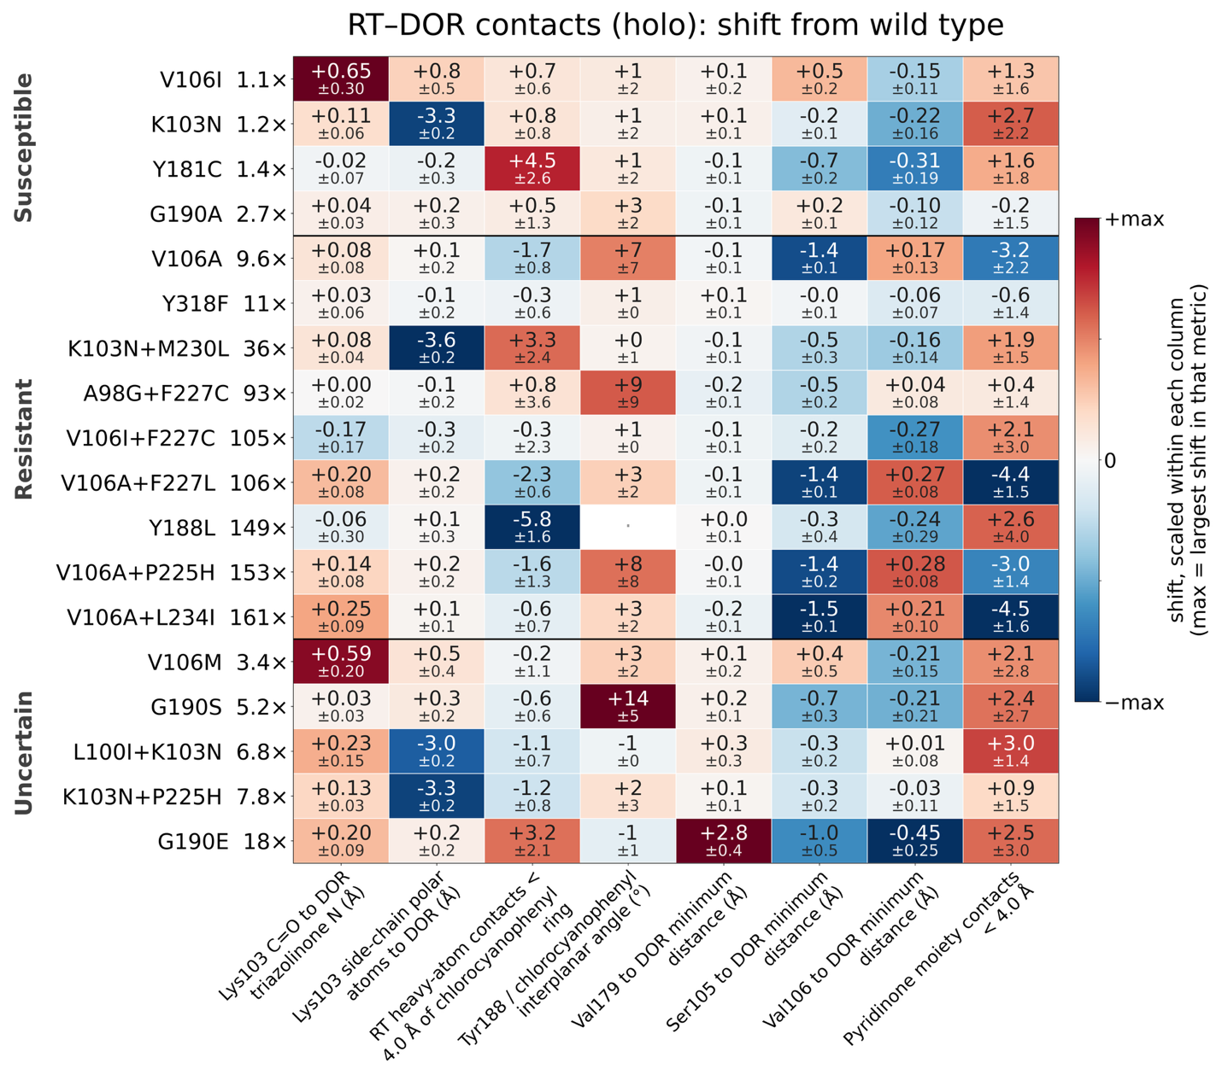
Figure 3: Structural features related to RT-DOR contacts extracted from equilibrium MD.
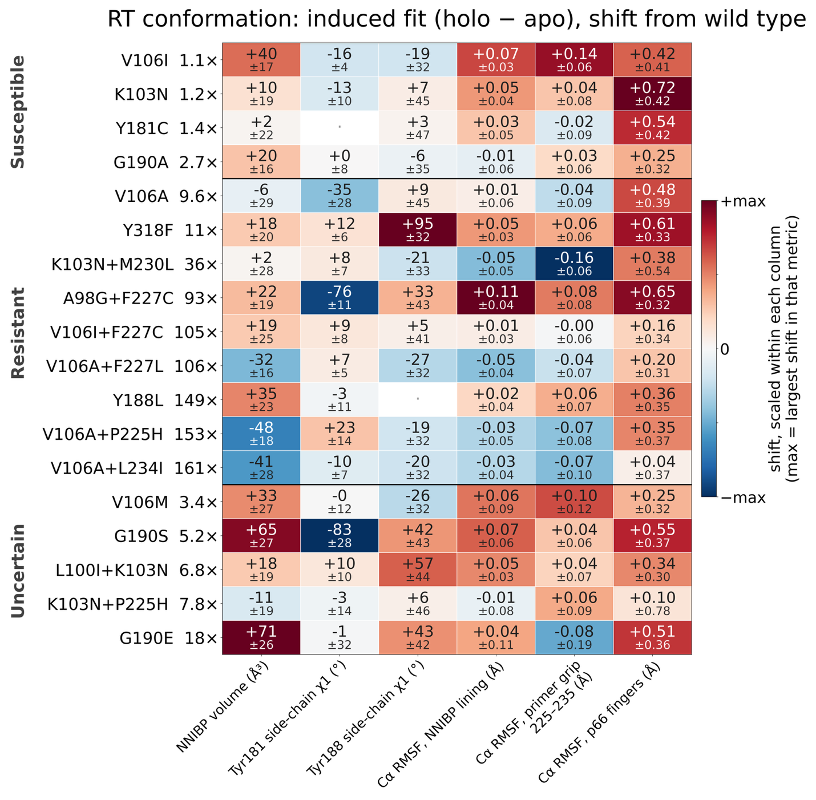
Figure 4: RT Structural features extracted from equilibrium MD simulations of the RT-DOR system in holo and apo configurations.”

Reviewer 2
Comments:
In this manuscript, the authors use all-atom MD simulations with alchemical FEP and MM/GBSA to retrospectively assess doravirine resistance across 18 clinically observed HIV-1 RT genotypes. FEP correctly predicts little effect for 3 of 4 susceptible mutations and reduced binding for 7 of 9 resistant genotypes, though correlations with experimental fold-change are weak (R² = 0.26, p = 0.07). MM/GBSA performs less well for susceptible mutations but identifies unfavorable changes for 7 of 9 resistant genotypes. Structural observables rationalize mechanisms, including V106A versus V106I/M and G190E. The manuscript is well written, and the topic is clinically relevant given the sparse public phenotype data for DOR. However, several methodological and interpretive issues need to be addressed before the manuscript can be considered for publication. Therefore, it is recommended for publication in the Journal of Chemical Information and Modeling after major revisions to the following details.
More comments:
Response: We thank the reviewer for the thoughtful and constructive comments.

Reviewer 2, comment 1
1. The three independent 100 ns replicates are short relative to the timescales of RT domain rearrangements and unliganded pocket conformational equilibria. The authors should provide more rigorous convergence diagnostics (e.g., block averaging, autocorrelation analysis) for both the structural observables and the FEP/MM-GBSA estimates, and discuss how limited sampling may bias the results.
Response:
To address this comment, we have performed the convergence diagnostics suggested by the reviewer. The details of the protocol are added to the Methods section:
“For a series of N successive frames of a structural observable, with values x_{t} and mean x̄, sampled at interval Δt, the normalized autocorrelation function (ACF) was computed as $C(τ)={\sum_{t=1}^{t=N-τ}{(x_{t}-\overline{x})(x_{t+τ}-\overline{x})}}/{\sum_{t=1}^{t=N}{{(x_{t}-\overline{x})}^{2}}}$, so that C(0) = 1; lags are reported as τΔt in nanoseconds. For block averaging, each series was partitioned into M = ⌊N/n⌋ non-overlapping blocks of length n with block means ${\overline{x}}_{b}=\frac{1}{n}\sum_{t=(b-1)n+1}^{t=bn}{x_{t}}$ where $b=1,2,...,M$. The standard error of the mean implied by that block length, also called the blocked standard error, is $SEM(n) = \sqrt{{\sum_{b}{{({\overline{x}}_{b}-\overline{x})}^{2}}}/{M(M-1)}}$. It rises with n and levels off once a block is longer than the correlation time of the observable, and that plateau is the standard error of the mean with correlation between frames accounted for. Block means were pooled across the three replicates of a genotype, so that even a 50 ns block yields six blocks from three 100 ns trajectories. Since g is the square of a ratio of estimated standard deviations, the interval shown on it is the chi-square interval on M − 1 degrees of freedom.”
The corresponding results are summarized in Supplementary Figure 3:
“ 3. Convergence of the molecular dynamics ensemble



Supplementary Figure 3. DOR Root Mean Squared Deviation (RMSD) and distance between centers of mass (COM) of DOR and RT indicate 100ns runtime is sufficient for DOR-RT interactions to stabilize. (A) Each solid line provides the average RMSD of the DOR heavy atoms vs the minimized structure within the NNIBP (at t = 0) computed at each time point across triplicate simulations. Shaded regions represent the standard error this mean (SEM). The red curve represents WT and the remaining trajectories are color-coded based on the respective genotype's fold-change in susceptibility (Table 1 in main text). Inset shows the same data highlighting the rapid changes in the first 5ns of the simulations. (B) Similar plot for the average distance between COMs of DOR and RT atoms. (C, D) Normalised autocorrelation functions of these two chosen convergence metrics, computed for each replicate and averaged within each genotype, with the shaded region showing the SEM across replicates. From these plots, DOR RMSD and the DOR-RT COM distance in our simulations decorrelate within about 5 ns and roughly 20 ns, respectively. (E, F) Blocked standard error of the convergence metrics against block length. The shaded band, drawn for wild type alone to keep the panel legible, is the 95% chi-square interval on a standard error estimated from that number of blocks. From these plots, the blocked error is nearly flat beyond 10 ns for DOR RMSD, but DOR-RT COM distance takes about 40-50 ns, up to the statistical limit of the trajectories simulated here.”

Reviewer 2, comment 2
2. The binary RT–DOR system omits the nucleic acid substrate and incoming dNTP, which are essential for resistance mechanisms involving the primer grip (e.g., M230L) and allosteric coupling (e.g., K103N). The authors should explicitly discuss which mechanisms are inaccessible in this setup and how this may affect the correlation with phenotypic data.
Response: We agree, and the revised Discussion states explicitly which mechanisms this setup forecloses.
To address this comment, we have extended this paragraph in the Discussion section:
“Several genotypes show inconsistencies between ∆∆ETotal and ∆∆Gbind, which is not surprising. The two measure different quantities, the interface energy of the bound complex versus the energetic difference between bound and unbound states.34 G190E and A98G+F227C both distort the DOR–RT interface (∆∆ETotal = 1.94 ± 0.40 and 2.47 ± 0.24 kcal/mol), but comparable distortion is present in the apo simulations, so the penalty largely cancels in the thermodynamic cycle and the residual favors binding (∆∆Gbind = −1.02 ± 0.38 and −1.53 ± 0.87 kcal/mol). Similarly, for K103N+M230L, our calculations suggest negligible binding penalty (∆∆Gbind = 0.59 ± 0.41 kcal/mol) despite a 36-fold reduction in susceptibility (Table 1). Structural metrics suggest DOR interface is unperturbed — chlorocyanophenyl burial is the second highest in the panel, 22.8 ± 2.4 against 19.5 ± 0.5 in WT, and the Lys103 anchor is intact at 3.05 ± 0.04 Å (Table 3). Interestingly, Met230 lies in the p66 primer grip, where its side chain contacts the primer terminus,79 and M230L impairs RT enzymatic function and viral replicative capacity in addition to reducing NNRTI susceptibility.80 Our system is a binary RT–DOR complex containing no template/primer, so a resistance mechanism acting through that interface is absent from our simulations and, therefore, outside the scope of our measurements. A change in the primer grip, in how the template is held, or in how often RT adopts a catalytically active shape would not affect ΔΔGbind or ΔΔETotal as measured in the present study, yet could still lower susceptibility in host cells. The same comparison localises what nucleic acid changes: with the p66 palm as the reference frame, p51, the fingers and the thumb differ by 1.6–2.2 Å between the two structures while the NNIBP lining differs by 0.97 Å, so the mechanisms we cannot reach without nucleic acid are those that act through those subdomains rather than through the drug site itself. For G190E a second factor concerns the phenotype rather than the calculation. Substitutions at position 190 impair replication severely: a site-directed G190E virus replicates too poorly for its NNRTI susceptibility to be determined at all, and patient-derived G190E viruses replicate at 20–60% of reference only because they carry compensatory substitutions elsewhere in RT and in Gag-PR, most often L74V or V75. The clinical fold-change we compare against is therefore measured on viruses that are not G190E alone, while our calculation changes one residue in an otherwise wild-type enzyme, so part of this mismatch is a difference in what is being measured.”
We have also added a sentence that localises what nucleic acid changes, using the comparison with the cryo-EM structure that has DNA bound:
“The sampling is a limitation of a different kind. Three 100 ns replicates are long relative to the local relaxation of the DOR pose, which converges within the first few nanoseconds, but short relative to the domain rearrangements of RT and to the conformational equilibrium of the unliganded pocket. Our replicates were seeded from the same crystallographic pose with only small coordinate perturbations, so they sample one conformational basin well rather than surveying the accessible landscape. Stable RMSD values, overlapping forward and reverse work distributions and small replicate-to-replicate errors establish convergence within that basin; they do not establish that the basin is the only relevant one. This distinction matters most for the NNIBP, which is an induced-fit pocket that does not exist in unliganded RT, because a mutation that shifts the conformational equilibrium of the apo enzyme, or the free-energy cost of opening the pocket, perturbs both legs of our thermodynamic cycle in the same direction and largely cancels. The three genotypes where ΔΔGbind misses the phenotype, K103N+M230L, A98G+F227C and G190E, are precisely those whose reported mechanisms are pre-binding or loop-mediated, which is what that cancellation would predict. We tested this directly against our apo simulations, which now run to 100 ns for every genotype. The unliganded pocket is substantially collapsed relative to the bound state (51–128 Å³ against 223–284 Å³ in Table 3). Between genotypes, however, the apo volume separates from wild type for only three, and all three are V106A-containing and all in the direction of a more open unliganded pocket: V106A by +52 ± 11 Å³ (p = 0.02), with V106A+F227L and V106A+P225H likewise. None of the three genotypes whose ΔΔGbind misses the phenotype differs from wild type at three replicates: G190E −15 ± 23 Å³, A98G+F227C −13 ± 11 Å³ and K103N+M230L +20 ± 26 Å³, the last in the opposite direction to a collapse. We therefore cannot support a pre-binding collapse of the pocket as the explanation for these mismatches, and we do not claim it. What the apo simulations do establish is that the V106A class arrives with the pocket already open, which is a mutation-induced change in the unliganded enzyme of exactly the kind the reviewer asks about. One replicate, V106A rep 2, reached only 34 ns and is excluded from the matched comparison. Across the panel the DOR heavy-atom RMSD from the crystallographic pose settles between 0.64 and 0.93 Å, wild type at 0.66 Å, so the complexes are stable but the ensembles do not visit alternative poses. That pose is not peculiar to the structure we started from: doravirine and the residues lining its pocket agree to 0.62 and 0.49 Å respectively between 4NCG and 7Z2G, an independent cryo-EM structure of RT with doravirine and DNA bound15 (Supplementary Figure 1), although the sampling limitation above applies to the basin around that pose regardless. We tested this directly. Four alternative DOR poses, 0.9 to 8.2 Å from the crystallographic one, were simulated without the 0.1 Å jitter; only the pose already inside the wild-type envelope after minimization stayed there, and extending the most displaced pose to 64 ns moved its median RMSD by 0.06 Å. The sampled basin is therefore the one we seed, which is the limitation stated above made quantitative rather than resolved.”
The point is that with the p66 palm as the reference frame, p51, the fingers and the thumb differ by 1.6 to 2.2 Å between the two experimental structures while the NNIBP lining differs by 0.97 Å. The mechanisms we cannot reach without nucleic acid are therefore those acting through those subdomains rather than through the drug site itself.

Reviewer 2, comment 3
3. Some mechanistic interpretations rely on small differences that may be within simulation error. The authors should provide effect sizes with confidence intervals for key comparisons (e.g., V106A vs. V106I/M, G190A vs. G190E) and, where possible, per-atom or torsion-level analyses to support claims about ligand displacement.
Response: We accept that several mechanistic statements rested on means with replicate standard errors. Rather than treat the comparisons the reviewer names as special cases, we now report an effect size and a 95% confidence interval for every genotype and every structural feature, in both the bound and unliganded states, using Welch intervals on the difference of replicate means with the replicate as the unit of replication (Supplementary Table 4). The intervals changed what we claim.
To address this comment, we have modified this paragraph in the Discussion section:
“In all four V106A-containing genotypes, DOR slides 1.3–1.5 Å toward Ser105, out of its crystallographic pose, and loses roughly a quarter of its pyridinone contacts (Figure 3B, Table 3). Residue 106 packs directly against the inhibitor in the hydrophobic palm pocket, and this contact has been proposed as a causal mechanism for NNRTI resistance in at least one prior study,77 consistent with V106A being the primary in vitro DOR resistance pathway, from which F227L and L234I subsequently emerge16 — the two genotypes with the lowest pyridinone contact counts in our panel. In contrast, in V106I and V106M, DOR is pushed away from Ser105 and pressed against residue 106, the pyridinone contact count does not fall, and the cost appears instead at the other end of the molecule: these are the only two genotypes in which the residue 103 backbone anchor lengthens appreciably, by roughly 0.6 Å against a distance otherwise constant to within 0.25 Å across all 18 mutants (Table 3). V106I and V106M account for the two largest apparent overestimates of ∆∆Gbind in the panel (+2.27 ± 0.74 and +6.10 ± 0.16 kcal/mol) against fold-changes of 1.1 and 3.4 (Table 1). Notably, however, in subtype C, V106M alone reduces DOR susceptibility 17-fold,78 and V106A/V106M is the primary resistance pathway in subtypes A and C as well as B.16 We quantified the uncertainty on these contrasts by treating the replicate as the unit of replication and computing Welch intervals on the difference of replicate means. The displacement toward Ser105 is well resolved: −1.35 Å [−1.73, −0.97] for V106A relative to WT and +1.85 Å [1.25, 2.45] for V106I relative to V106A, with Hedges' g near 9 in both cases. The accompanying changes in pyridinone contact count are directionally consistent but not resolved at three replicates (−3.2 contacts [−9.3, +2.9] for V106A relative to WT), and the V106A versus V106M contrast is within error on every metric we examined. We therefore rest the V106 argument on the displacement, which the replicates support, rather than on the contact counts, which they do not.”
Treating the replicate as the unit of replication, the displacement toward Ser105 is well resolved: −1.35 Å [−1.73, −0.97] for V106A relative to wild type and +1.85 Å [1.25, 2.45] for V106I relative to V106A, with Hedges' g near 9 in both cases. The accompanying change in pyridinone contact count is directionally consistent but not resolved at three replicates, and the V106A versus V106M contrast is within error on every metric we examined. We therefore rest the V106 argument on the displacement and say so.
For the torsion-level support the reviewer asks for, the four rotatable dihedrals of DOR are analysed with circular statistics across all replicates; the results are in the Supporting Information.

Reviewer 2, comment 4
4. The FEP calculations involve two charge-changing legs (WT → K103N, WT → G190E). The authors should verify that protonation states of titratable residues in the NNIBP are consistent across WT and mutants, and provide more detail on the hybrid residue topologies, soft-core parameters, and finite-size correction.
Response: To address this comment, we have added this text in the Methods section:
“Titratable residues were assigned in the prepared wild-type structure and carried unchanged through mutation modeling, so no titratable residue differs between the end states of any leg. All thirteen histidines are neutral with the proton on Nδ1, in the wild type and in all 18 genotypes. The glutamate introduced by G190E is deprotonated and singly charged, which is what makes that leg charge-changing. In the hybrid topologies, bonded parameters are interpolated linearly in λ and dummy atoms are relaxed during the end-state minimization. Soft-core parameters were α = 0.3, σ = 0.25 nm and a soft-core power of 1, applied to both Lennard-Jones and Coulomb interactions.”
As well as the following section in the Supplementary Text:
“ 5. Finite-size corrections for the charge-changing alchemical legs
The leading periodicity (net-charge self-energy) term of the Rocklin scheme is +0.0407 kcal/mol per phase and cancels to below 0.0001 kcal/mol in ΔΔG_{bind} for both WT→K103N and WT→G190E. The higher-order terms — net-charge undersolvation, discrete-solvent and residual integrated potential — were not applied, since computing them exactly requires a Poisson-Boltzmann treatment of each environment. However, the charge change is identical in the holo and apo phases by construction; and the cells are matched to within 0.13% (K103N) and 0.31% (G190E) in volume, with DOR occupying 0.019% of the cell. Taking a per-phase correction of 1 kcal/mol, about 25 times the leading term, the residual on ΔΔG_{bind} is at most 0.003 kcal/mol — two to three orders of magnitude below the 0.2–1.2 kcal/mol per-leg statistical uncertainties in Table 2.”

Reviewer 2, comment 5
5. Gasteiger charges are less accurate than AM1-BCC or RESP for drug-like molecules. The authors should either compare with a more accurate charge model for a subset of systems or explicitly discuss how this choice may affect the computed energies and the resulting correlations.
Response: We thank the reviewer for pointing this out. This comment helped reveal a documentation error in the Methods section that is now corrected:
“DOR was parameterized for the alchemical legs with the OpenFF 2.0.0 force field and its default AM1-BCC partial charges, then exported to GROMACS format through OpenFF Interchange 0.5.0.”
To address this comment, we have added a new section in the Supplementary Text:
“ 6. Sensitivity of the MM/GBSA energies to the ligand charge model
DOR parameters for the equilibrium MD simulations were generated with Gasteiger partial charges, as opposed to AM1-BCC for the FEP simulations. To test how much that choice matters, the same trajectories and snapshots were re-scored with AM1-BCC charges for a subset of genotypes (see Supplementary Table 6). The two charge sets are both neutral and generally correlate well, but AM1-BCC is more polarized (mean |q| = 0.228e against 0.138e; RMS difference 0.165e, maximum 0.390e), with the largest differences on the triazolinone and pyridinone carbonyl and amide atoms. The WT-referenced ΔΔE_{Total} changed by at most 0.81 kcal/mol and kept its sign for every genotype tested. The charge model was found to largely affect the electrostatic, ∆∆E_{elec}, and the polar solvation, ∆∆E_{GB}, terms. [PENDING: extended to more genotypes]”
Reviewer 3
Comments:
The topic of this manuscript is timely and clinically relevant, the genotype panel is thoughtfully curated with transparent provenance (Stanford HIVDB, PhenoSense/Merck assays), and the use of open-source tooling (OpenMM, GROMACS, pmx, OpenFF) is commendable for reproducibility. The manuscript is generally well written and the structural analysis is a genuine strength. However, the central quantitative claim — that FEP "partially tracks" phenotype — rests on weak statistics derived from a small panel, and several methodological choices and interpretive statements require clarification, additional support, or tempering before the work can be considered suitable for publication. My specific concerns follow:
Response: We thank the reviewer for their comments. We have transparently justified our methodological choices and clarified our interpretations in the updated manuscript.

Reviewer 3, comment 1
1. The Abstract states "FEP correctly predicted little effect on DOR binding for 3 of 4 susceptible mutations and reduced binding for 7 of 9 resistant genotypes." Please define "correctly predicted" quantitatively — what threshold on ΔΔG_{bind} constitutes "little effect" versus "reduced binding"? A stated cutoff (e.g., | ΔΔG_{bind}| > 1 kcal/mol) would make this claim reproducible.
Response: To clarify the origin of our chosen threshold for “little effect” vs “reduced binding”, we have updated the Abstract:
“…Results: Using a cutoff of ΔΔG_{bind} = +0.5 kcal/mol, approximately the thermal energy (k_{B}T) at 300 K, FEP correctly predicted little effect on DOR binding for 3 of 4 susceptible mutations and reduced binding for 7 of 9 resistant genotypes….”
And added a statement in the Methods section:
“Agreement with phenotype was additionally summarized as a binary classification. A genotype was scored as predicted-resistant when the computed quantity (binding free energy or DOR-RT interaction energy), minus its standard error over replicates, exceeded +0.5 kcal/mol, approximately k_{B}T at 300 K, and as predicted-susceptible otherwise. This cutoff was fixed a priori rather than fitted to the panel.”

We also quote this unedited statement from the Results section:
“Throughout this work, we classify a genotype as having a strong impact on ∆∆G_{bind} or ∆∆E_{Total} when its estimate lies more than one standard error above (approximately) the thermal energy at room temperature, k_{B}T = 0.5 kcal/mol, and as having a weak impact otherwise; genotypes with free energy below this threshold or whose replicate error spans this threshold are therefore counted as weak.”

Reviewer 3, comment 2
2. There are several minor typographical issues: "NRNTI-resistance mutations" (Page 16) should be "NNRTI-resistance mutations"; "hinges on" (Page 30) should be "hinges on" or "depends on"; "APPROVAL" section header (Page 35) is redundant with "Author Contributions." Please proofread carefully.
Response: We have proofread the manuscript in full and corrected the errors found.
On the three specific items, we were unable to locate the strings “NRNTI-resistance mutations” or an “APPROVAL” section header in our submitted manuscript file or Supporting Information, and we suspect these arose in the typeset proof rather than in our source. We would be glad to correct them if the editor can point us to the page in the version the reviewer read. The third item, “hinges on”, appears in the Discussion and has been rewritten.

Reviewer 3, comment 3
3. The MM/GBSA protocol minimizes each snapshot with all atoms free before energy evaluation (Page 11). This is unusual: standard MM/GBSA evaluates single-point energies on snapshots (or after minimizing only hydrogens) to avoid artificially distorting the ensemble. Full minimization of 100 snapshots per trajectory can substantially reduce energetic noise and may bias ΔΔE components, particularly ΔE_{elec} and ΔE_{GB}. The authors should:
(a) Justify full minimization versus the more standard single-point or hydrogen-only relaxation protocol.
(b) Report how sensitive ΔΔE_{Total} and its components are to this choice (e.g., by recomputing without minimization for a subset of genotypes).
Response: (a) To address this comment, we have added this text in the Methods section:
“Minimizing each snapshot before the energy evaluation follows established practice for end-point methods. Minimization-based MM-PBSA has been validated for drug discovery,⁴⁶ minimization-based MM-PBSA and MM-GBSA have been shown to reproduce the accuracy of ensemble averaging at a fraction of the cost,⁴⁷ and minimizing from a series of MD snapshots, as done here, has been shown to give results similar to single-point ensemble averages.^{34,48} Minimization relieves steric strain that single-point evaluation of frames sampled under explicit solvent, periodic boundary conditions and constrained bond lengths would otherwise carry into the cutoff-free, unconstrained implicit-solvent Hamiltonian used for scoring, where it contributes Lennard-Jones energies far larger than the binding signal. We chose to minimize with all atoms free rather than restraining heavy atoms. Because this choice can reduce energetic noise and shift individual components, we report the sensitivity of ΔΔE_{Total} and of each component to it, recomputing a subset of genotypes under single-point evaluation and under hydrogen-only relaxation with heavy atoms restrained (Supplementary Section 7 and Supplementary Table 5). Note that this choice only affects the MM/GBSA calculations; ΔΔG_{bind} is an alchemical free energy and involves no snapshot minimization.”
(b) To address this comment, we have added a new Supplementary Table 5 and this new section in the Supplementary Text:
“
- Sensitivity of the MM/GBSA energies to the snapshot relaxation protocol
Each snapshot is energy-minimized before its energy is evaluated. We compared hydrogen-only relaxation, with heavy atoms restrained, against the unrestrained full minimization used in the main text, for all 19 mutant genotypes (Supplementary Table 5). The two protocols agree on the terms that do not depend on close atomic contacts: the Spearman correlation between them is 0.69 for ΔΔE_{elec} and 0.81 for ΔΔE_{GB}. This is not the case for ΔΔE_{vdW} (0.26) or ΔΔE_{Total} (0.09). We find that hydrogen-only relaxation leaves heavy-atom contacts in place, and those contacts enter the van der Waals term, which dominates total MM/GBSA computed interaction energy shifts. Furthermore, over the 13 genotypes with an established phenotype, ΔΔE_{Total} from full minimization correlates with log₁₀ fold reduction in DOR susceptibility at Spearman +0.45 (p = 0.13), while hydrogen-only relaxation gives -0.32 (p = 0.29), though neither reaches statistical significance. For completeness, we also tested single-point evaluation, with no relaxation at all, on six genotypes. In these cases, we found that ΔΔE_{Total} is dominated by a small number of snapshots carrying steric contacts, reaching 7 × 10⁸ kcal/mol in the worst case. Our view is ΔΔE_{Total} is not interpretable until close heavy atom contacts are relieved.
”

